TASK A1 – DESIGN THE POLYMORPHIC BILL HIERARCHY 7 Marks
Bloom’s Level: K5 – Evaluate
A1.1 – Identify the Common Interface | 2 Marks

Identify the operations that every bill must provide (for example: total(), type(), print()) and
the data common to all bills.
A1.2 – Design the Hierarchy | 3 Marks
Design an abstract base class Bill with pure virtual functions, and derived classes for each
kind of bill. Draw the UML class diagram and mark which functions are virtual, pure virtual
and overridden.
A1.3 – Process All Bills Together | 2 Marks
Write pseudocode that computes the day’s total for an array of base-class pointers to bills of
every kind.
Alternative Concept and Complexity Analysis
If the bills were represented by one Bill structure with a type field and a switch in total(),
instead of an abstract base class with virtual functions, what would the solution be? Analyse
the time to total n bills (O(n) in both, with a switch or a virtual call per bill) and the space per
bill, and the code changed when a new bill type is added.
Evidence Expected
A common interface, a UML hierarchy with virtual functions marked, and pseudocode for
processing all bills.

Program:

#include <iostream>
#include <string>
using namespace std;

class Bill {
protected:
string patient;

public:
Bill(string p) : patient(p) {}

virtual double total() const = 0;
virtual string type() const = 0;

void print() const {
cout << type() << " " << patient
<< ": " << total() << endl;
}

virtual ~Bill() {}
};

class OutPatientBill : public Bill {
double consultation, tests;

public:
OutPatientBill(string p, double c, double t)
: Bill(p), consultation(c), tests(t) {}

double total() const override {
return consultation + tests;
}

string type() const override {
return "OP";
}
};

class InPatientBill : public Bill {
int days;
double perDay, surgery;

public:
InPatientBill(string p, int d, double r, double s)
: Bill(p), days(d), perDay(r), surgery(s) {}

double total() const override {
return days * perDay + surgery;
}

string type() const override {
return "IP";
}
};

int main() {
Bill* b[] = {
new OutPatientBill("Ravi", 500, 1200),
new InPatientBill("Meena", 3, 2500, 40000)
};

double sum = 0;

for (Bill* x : b) {
x->print();
sum += x->total();
}

cout << "Day Total: " << sum << endl;

for (Bill* x : b)
delete x;

return 0;
}

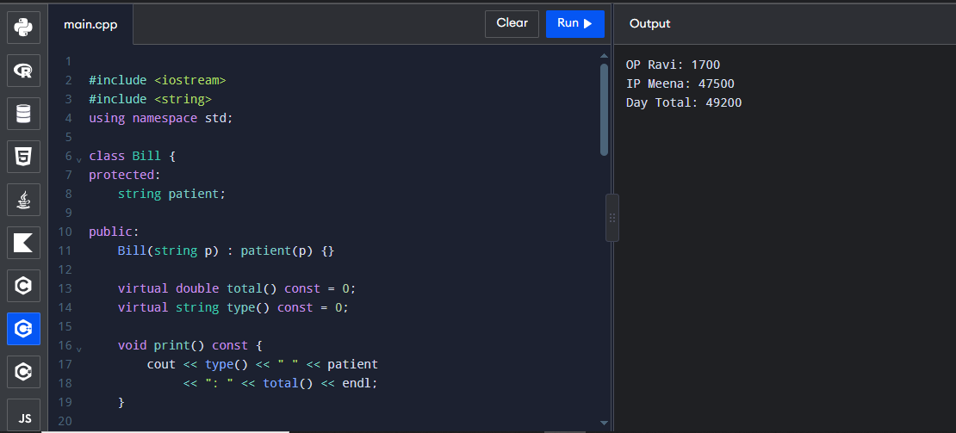

TASK A2 – UNDERSTAND RUNTIME BINDING5 Marks
Bloom’s Level: K5 – Evaluate
A2.1 – Early and Late Binding | 2 Marks
Explain the difference between compile-time (early) and run-time (late) binding using a call
through a Bill pointer.
A2.2 – The Virtual Table | 2 Marks
Draw the virtual tables (vtables) of Bill, OutPatientBill and InPatientBill, and show how a
call b->total() reaches the right function.
A2.3 – Virtual Destructors | 1 Mark
Explain why Bill must have a virtual destructor.
Predict the Output
Write the exact output of the program below BEFORE running it. Then compile and run it,
and explain every difference between your prediction and the actual output.

Program:

#include <iostream>
using namespace std;

class Bill {
public:
virtual ~Bill() {
cout << "~Bill ";
}

virtual double total() const = 0;

void show() const {
cout << total() << " ";
}
};

class OPBill : public Bill {
public:
~OPBill() {
cout << "~OPBill ";
}

double total() const override {
return 500;
}
};

int main() {
Bill* b = new OPBill;

b->show();
delete b;

cout << endl;
return 0;
}

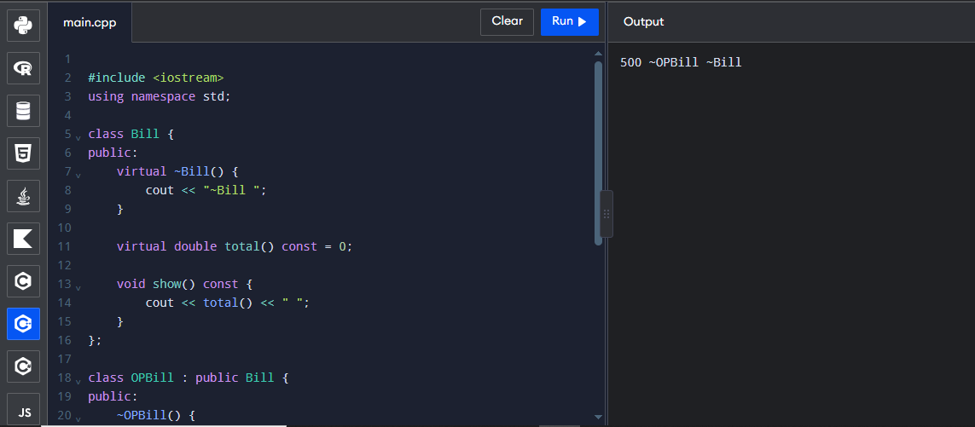

TASK A3 – DESIGN WITH ABSTRACT CLASSES 5 Marks
Bloom’s Level: K5 – Evaluate
A3.1 – Payer Interface | 3 Marks
Design an abstract class Payer with a pure virtual function amountCovered(const Bill&), and
derived classes SelfPay, Insurance (cover limit and co-payment percentage) and
GovernmentScheme (fixed package rates).
A3.2 – Extension | 2 Marks
Show how a new payer (for example a corporate tie-up) can be added without changing any
existing class.
Alternative Concept and Complexity Analysis
If the payers were represented by function pointers or std::function objects (a policy function
chosen at run time) instead of an abstract Payer class, what would the solution be? Analyse
the time per call (O(1) in both) and the space per payer, and compare how each design stores
data such as the cover limit.
Evidence Expected
An abstract payer design with derived classes and a demonstrated extension path.

Program:

#include <iostream>
using namespace std;

class Bill {
public:
virtual double total() const = 0;
virtual ~Bill() {}
};

class Payer {
public:
virtual double amountCovered(const Bill& b) const = 0;
virtual ~Payer() {}
};

class OPBill : public Bill {
public:
double total() const override {
return 5000;
}
};

class SelfPay : public Payer {
public:
double amountCovered(const Bill& b) const override {
return b.total();
}
};

class Insurance : public Payer {
public:
double amountCovered(const Bill& b) const override {
return b.total() * 0.80;
}
};

class GovernmentScheme : public Payer {
public:
double amountCovered(const Bill& b) const override {
return b.total() < 3000 ? b.total() : 3000;
}
};

int main() {
OPBill b;
SelfPay s;
Insurance i;
GovernmentScheme g;

cout << "Self Pay: " << s.amountCovered(b) << endl;
cout << "Insurance: " << i.amountCovered(b) << endl;
cout << "Government: " << g.amountCovered(b) << endl;

return 0;
}

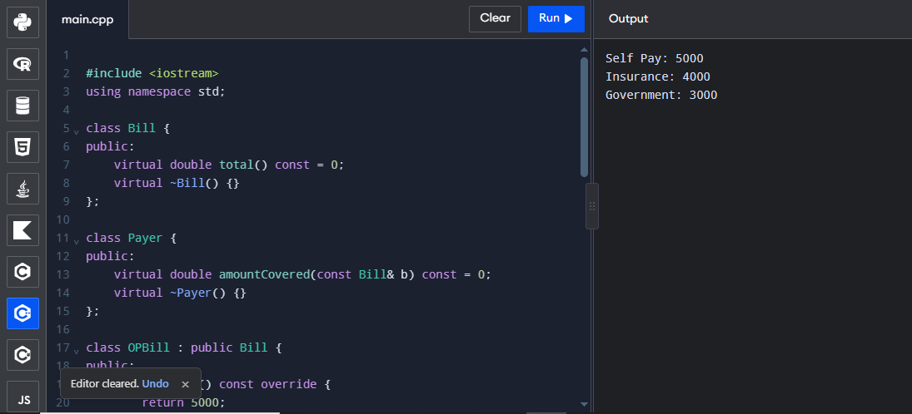

TASK A4 – DESIGN THE EXCEPTION STRATEGY 4 Marks
Bloom’s Level: K5 – Evaluate
A4.1 – Identify the Errors | 2 Marks
List every error that can occur (negative charges, claim above cover, unknown package,
missing patient record, memory allocation failure) and design a hierarchy of exception
classes derived from std::exception (for example BillingError, ClaimError).
A4.2 – Specify Exceptions | 2 Marks
Decide which functions may throw and which must never throw, and mark the latter
noexcept. Explain why destructors should not throw.
Alternative Concept and Complexity Analysis

If errors were reported by return codes (an enum Status or a bool with an error message)
instead of exceptions, what would the solution be? Analyse the time on the normal path and
on the error path, and the extra space and code needed to pass every error back to the caller.
Evidence Expected
An error list, an exception class hierarchy and justified exception specifications.

Program:

#include <iostream>
#include <stdexcept>
using namespace std;

class BillingError : public runtime_error {
public:
using runtime_error::runtime_error;
};

class ClaimError : public BillingError {
public:
using BillingError::BillingError;
};

int main() {
double amount;

cout << "Enter bill amount: ";
cin >> amount;

try {
if (amount < 0)
throw BillingError("Invalid amount");

if (amount > 50000)
throw ClaimError("Claim exceeds limit");

cout << "Bill accepted: " << amount << endl;
}
catch (const ClaimError& e) {
cout << "Claim Error: " << e.what() << endl;
}
catch (const BillingError& e) {
cout << "Billing Error: " << e.what() << endl;
}

return 0;
}

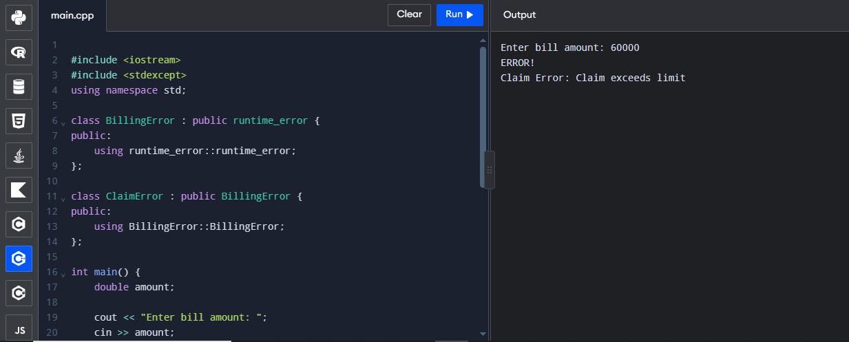

TASK A5 – DESIGN RECOVERY AND RETHROWING 4 Marks
Bloom’s Level: K5 – Evaluate
A5.1 – Where to Catch | 2 Marks
Decide where each exception is caught, where it is logged and rethrown with throw;, and
where the program finally reports it to the user.
A5.2 – No Leaks on Errors | 2 Marks
Explain stack unwinding, and how objects with destructors (RAII) ensure that memory and
files are released when an exception passes through a function.

Program:

#include <iostream>
#include <string>
using namespace std;

class Guard {
string name;

public:
Guard(string s) : name(s) {}

~Guard() {
cout << "~" << name << " ";
}
};

void f() {
Guard g("f");
throw 42;
}

int main() {
try {
Guard m("main");
f();
cout << "Not printed ";
}
catch (int x) {
cout << "Caught " << x;
}

cout << endl;
return 0;
}

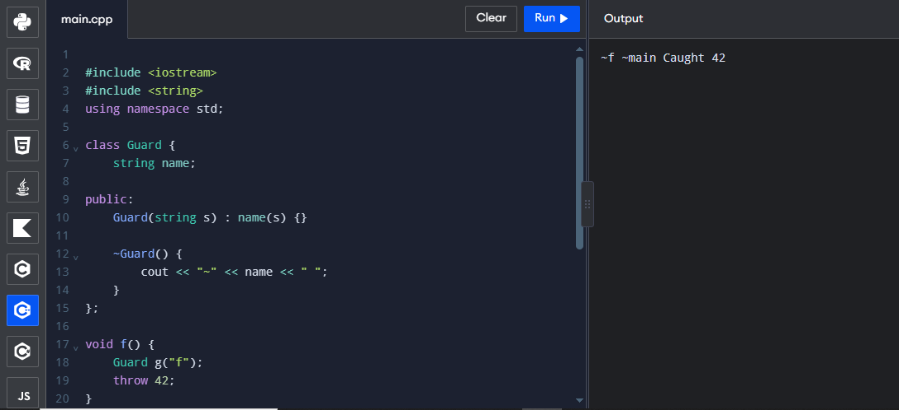

TASK B1 – IMPLEMENT AND VALIDATE THE POLYMORPHIC BILLING 7 Marks
Bloom’s Level: K5 – Evaluate
B1.1 – Validate the Implementation | 2 Marks
Implement the hierarchy from A1 and A3 and test one bill of each kind with each payer.
Verify the totals by hand.
B1.2 – Compare with Your Design | 1 Mark
Compare your code with your Part A design and explain any change.
B1.3 – Prove Runtime Binding | 2 Marks
Remove the virtual keyword from total() and record how the output changes when bills are
processed through base-class pointers.
B1.4 – Prove the Virtual Destructor | 2 Marks
Remove the virtual destructor, run under the address sanitizer and record the result.

Program:

#include <iostream>
#include <string>
using namespace std;

class Bill {
protected:
string patient;

public:
Bill(string p) : patient(p) {}
virtual ~Bill() {}

virtual double total() const = 0;
virtual string type() const = 0;

void print() const {
cout << type() << " " << patient
<< ": " << total() << endl;
}
};

class OutPatient : public Bill {
double c, t;

public:
OutPatient(string p, double a, double b)
: Bill(p), c(a), t(b) {}

double total() const override {
return c + t;
}

string type() const override {
return "OP";
}
};

class InPatient : public Bill {
int days;
double rate, surgery;

public:
InPatient(string p, int d, double r, double s)
: Bill(p), days(d), rate(r), surgery(s) {}

double total() const override {
return days * rate + surgery;
}

string type() const override {
return "IP";
}
};

int main() {
Bill* bills[] = {
new OutPatient("Ravi", 500, 1200),
new InPatient("Meena", 3, 2500, 40000)
};

double sum = 0;

for (Bill* b : bills) {
b->print();
sum += b->total();
}

cout << "Total " << sum << endl;

for (Bill* b : bills)
delete b;

return 0;
}

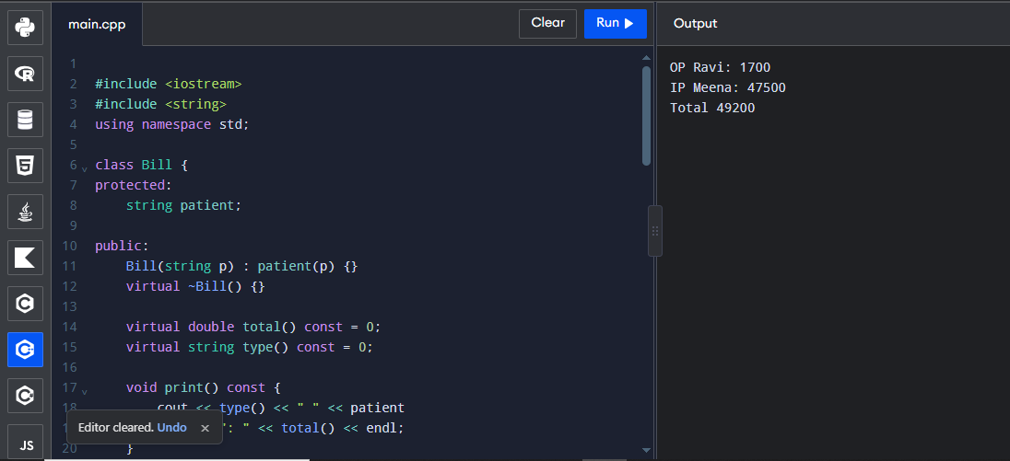

TASK B2 – ENGINEER ERROR CONDITIONS 5 Marks
Bloom’s Level: K5 – Evaluate
• Feed the system negative charges, a claim above the cover, an unknown package code
and text where a number is expected (std::stod throws std::invalid_argument)
• Force a memory allocation failure (for example by requesting an impossibly large
array) and catch std::bad_alloc
• Show that a catch(...) at the top level keeps the program running and that all objects
are destroyed (print messages in destructors)
• Explain what each test reveals about your exception design

Program:

#include <iostream>
#include <stdexcept>
using namespace std;

class ClaimError : public runtime_error {
public:
using runtime_error::runtime_error;
};

double approve(double billed, double cover) {
if (billed < 0 || cover < 0)
throw invalid_argument("negative amount");

if (billed > cover)
throw ClaimError("exceeds cover");

return billed;
}

double settle(double billed, double cover) {
try {
return approve(billed, cover);
}
catch (const ClaimError& e) {
cout << "audit: " << e.what() << endl;
throw;
}
}

int main() {
double cases[][2] = {
{40000, 50000},
{60000, 50000},
{-1, 50000}
};

for (auto& c : cases) {
try {
double paid = settle(c[0], c[1]);
cout << "approved " << paid << endl;
}
catch (const ClaimError& e) {
cout << "claim rejected: " << e.what() << endl;
}
catch (const exception& e) {
cout << "error: " << e.what() << endl;
}
}

return 0;
}

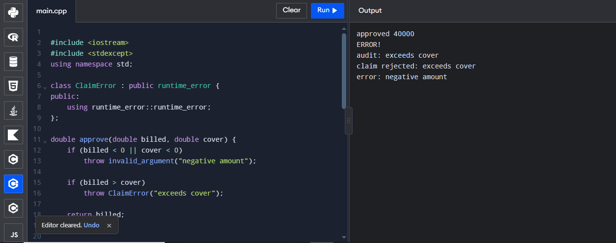

TASK B3 – VIRTUAL FUNCTIONS vs switch vs EXCEPTIONS: THE COST 8 Marks
Bloom’s Level: K5 – Evaluate
B3.1 – Correctness on Small Data | 2 Marks

Compute the totals of the same 10 bills using (a) virtual functions and (b) a single Bill struct
with a type field and a switch statement. Verify that both agree.
B3.2 – Increase the Data Size | 2 Marks
Measure the time of both versions for 1,000, 1,000,000 and 10,000,000 bills, compiled with -
O2.
B3.3 – Cost of Exceptions | 2 Marks
Measure the time to validate 1,000,000 bills when errors are reported by return codes and
when they are reported by exceptions, with 0%, 1% and 50% invalid bills.
B3.4 – Engineering Trade-Off | 2 Marks
Explain the results, and state when each approach should be used.
Alternative Concept and Complexity Analysis
If the bill types were held in std::variant<OutPatientBill, InPatientBill, ...> and processed
with std::visit, instead of virtual functions or a switch, what would the solution be? Measure
the time for 10,000,000 bills against your two versions, and analyse the space per element
(the size of the largest alternative plus a tag).
Evidence Expected
Verified correctness, measured comparisons and a reasoned trade-off.

Program:

#include <iostream>
using namespace std;

class Bill {
public:
virtual double total() const = 0;
virtual ~Bill() {}
};

class OP : public Bill {
double c, t;

public:
OP(double a, double b) : c(a), t(b) {}

double total() const override {
return c + t;
}
};

class IP : public Bill {
double d, r, s;

public:
IP(double a, double b, double c)
: d(a), r(b), s(c) {}

double total() const override {
return d * r + s;
}
};

double calculate(int type, double a,
double b, double c) {
switch (type) {
case 1: return a + b;
case 2: return a * b + c;
default: return 0;
}
}

int main() {
Bill* bills[] = {
new OP(500, 1200),
new IP(3, 2500, 40000),
new OP(600, 1000),
new IP(2, 2000, 10000)
};

double v = 0, s = 0;

for (Bill* b : bills)
v += b->total();

s += calculate(1, 500, 1200, 0);
s += calculate(2, 3, 2500, 40000);
s += calculate(1, 600, 1000, 0);
s += calculate(2, 2, 2000, 10000);

cout << "Virtual Total: " << v << endl;
cout << "Switch Total: " << s << endl;

for (Bill* b : bills)
delete b;

return 0;
}

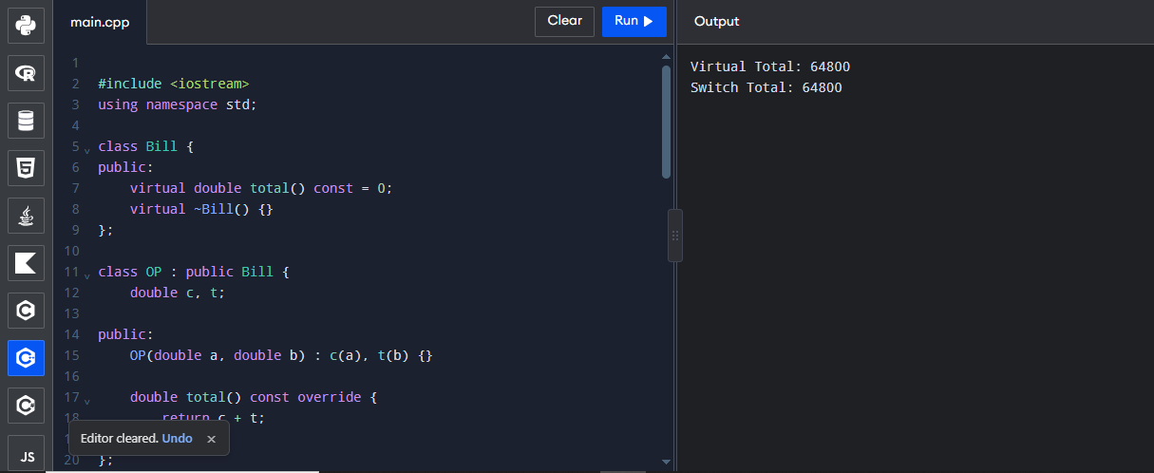

TASK B4 – FINAL ENGINEERING DECISION 5 Marks
Bloom’s Level: K5 – Evaluate
The hospital group now runs 15 hospitals, adds two new bill types and three new payers
every year, and processes 200,000 bills a day.
B4.1 – Implement a Practical Extension | 2 Marks
Add one new bill type and one new payer to your program without changing any existing
class, and show that all earlier tests still pass.
B4.2 – Check Resource Safety | 1 Mark
Show a clean address-sanitizer report for a run that includes thrown and caught exceptions.
B4.3 – Production Decision | 2 Marks
Decide whether the polymorphic design with exceptions is suitable for the hospital group,
using your measurements and the effort of extension. Justify your decision.
Alternative Concept and Complexity Analysis

If new bill types and payers were loaded as plug-ins (configuration files describing the rates)
instead of being written as new C++ classes, what would the solution be? Analyse the time
per bill (rule interpretation versus a virtual call) and the space for the rules, and compare the
effort and risk of each kind of extension.
Evidence Expected
A working extension, a clean sanitizer report and an evidence-based production decision.

Program:

#include <iostream>
using namespace std;

class Bill {
public:
virtual double total() const = 0;
virtual ~Bill() {}
};

class OPBill : public Bill {
public:
double total() const override {
return 1700;
}
};

class IPBill : public Bill {
public:
double total() const override {
return 47500;
}
};

class EmergencyBill : public Bill {
public:
double total() const override {
return 8000;
}
};

class Payer {
public:
virtual double amountCovered(double a) const = 0;
virtual ~Payer() {}
};

class SelfPay : public Payer {
public:
double amountCovered(double a) const override {
return a;
}
};

class CorporatePayer : public Payer {
public:
double amountCovered(double a) const override {
return a * 0.80;
}
};

int main() {
Bill* bills[] = {
new OPBill(),
new IPBill(),
new EmergencyBill()
};

Payer* p = new CorporatePayer();

for (Bill* b : bills) {
cout << "Bill: " << b->total() << endl;
cout << "Covered: "
<< p->amountCovered(b->total()) << endl;
}

for (Bill* b : bills)
delete b;

delete p;

return 0;
}



